**Name: Vishal Jha**

**Batch: Data Engineering**

**Date: 24/01/2024**

**Topic: MYSQL(AGGREGATION,OVER,PARTITION,REGEX,SUBTOTALS,MATERIALIZED VIEWS)**

Solution:

1. MYSQL:

**Total Aggregations using SQL Queries:**

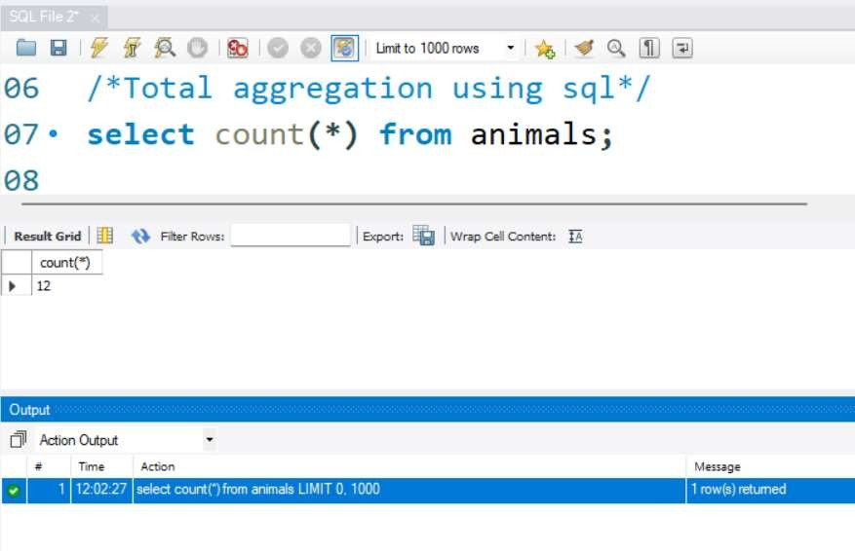

**OVER CLAUSE:**

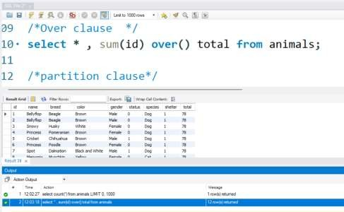

PARTITION CLAUSE

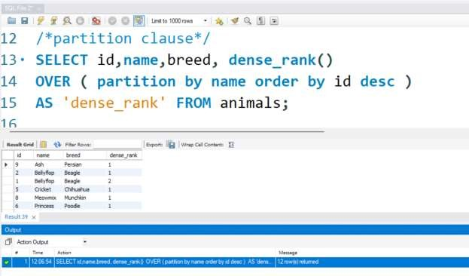

total aggregation using over & partition:

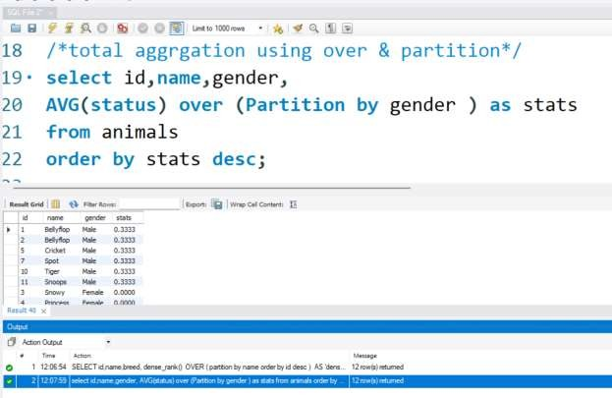

ORDER OF EXECUTION:

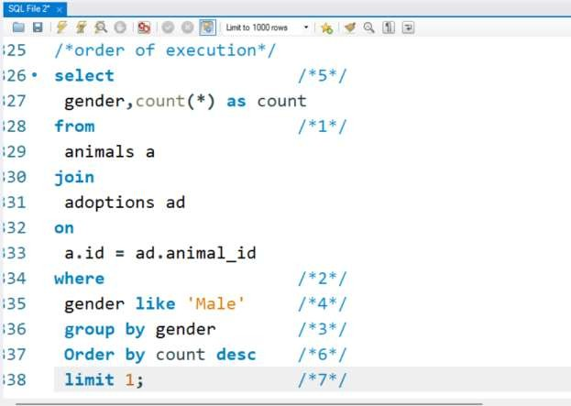

OUTPUT:

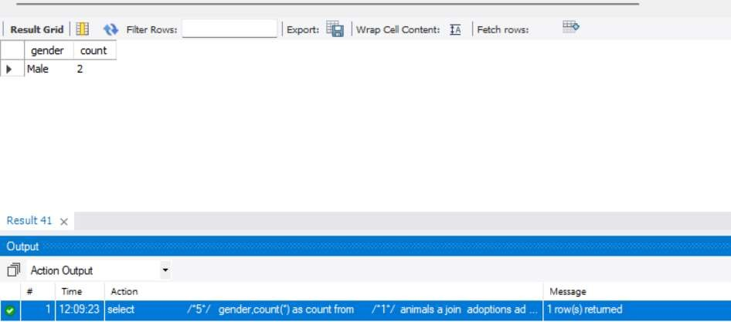

SUBTOTALS:

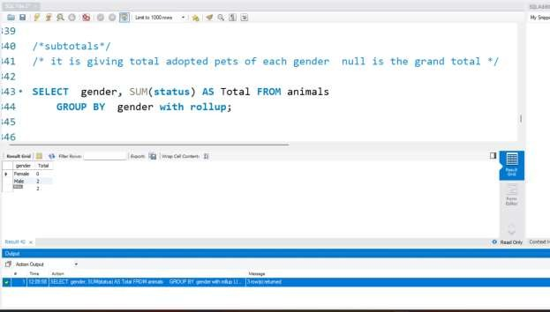

REGEX:

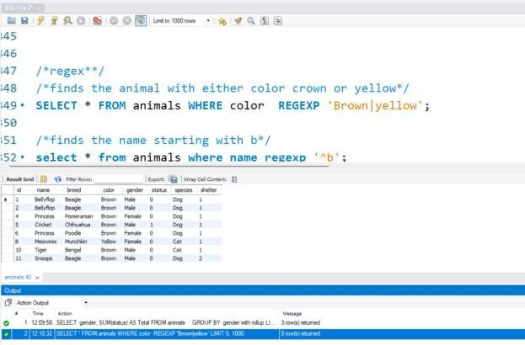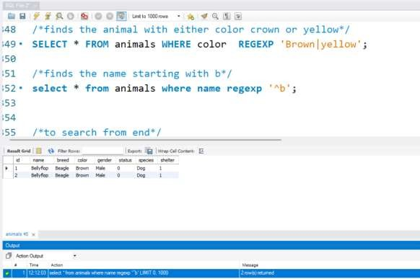

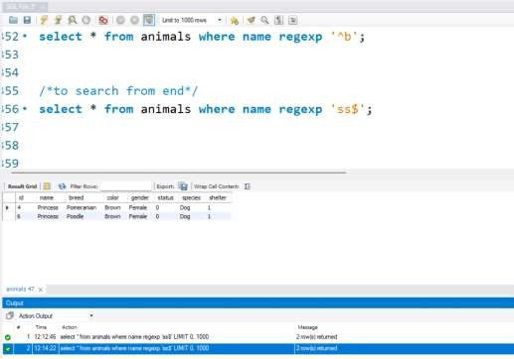

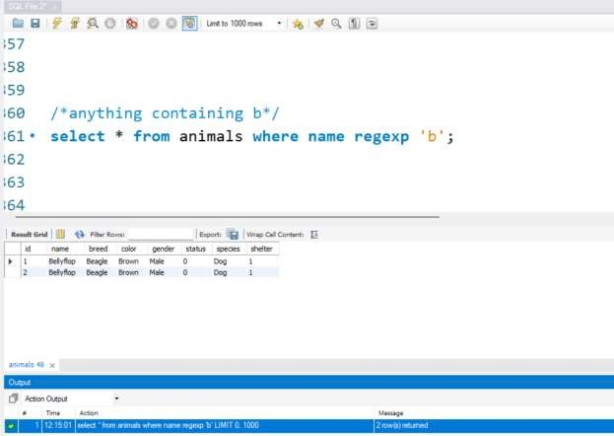

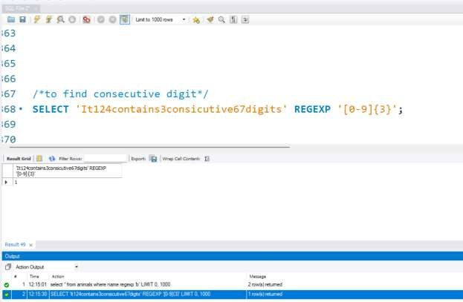

MATERIALIZED VIEW:

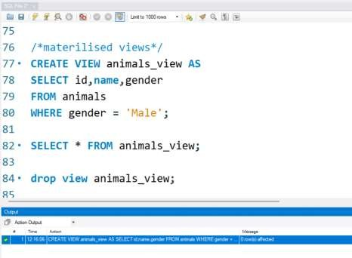

RETRIVEING VIEWS:

